Project - SCRAMBLE | POWER IDE beta 1.0.0  2010
Developers: Saileswar Kumar Mahakud  Smruti Ranjan Padhy  Sanjaya Kumar Behera |  | Multilingual Integrated  Development  Environment

INTRODUCTION
Long long ago once upon a time, a man named Blaise Pascal invented the calculating machine in some corner of the world; that event initiated a revolution in how mathematical computations were performed by devices. After years of research big, voluminous computing machines were developed known as computers.
It was a time when programming those large machines meant rewiring physically one module with another; with the passage of time further significant development were made and the so called computers were programmed with the help of software’s (the era of punched cards).

Cutting back to 1970s somewhere at Bell Labs a programming language named B was written by Ken Thompson for the first UNIX system on a DEC-PDP-7. Couple of years later in 1972 Dennis Ritchie invented and first implemented C on a DEC-PDP-11 that used UNIX operating system. C was developed as a general purpose language, with ideas being derived from BCPL (developed by Martin Richards, that gave rise to B) initially targeted for UNIX based systems only, since the system and most of the programs that run on it are written in C.

Today, the widely used programming languages are C, C++, Java, Scripting languages like HTML, Jscript, VB script and so on. Each of them offers a unique methodology of problem solving aspect, so each one comes up with its native editor, compiler and binary file generator. This Integrated Development Environment, Code Named – “Project SCRAMBLE”, is designed to provide a cross-culture platform where more than one programming languages can be used to create, compile and build programs.

OBJECTIVE: Computers are usually used for solving immense computational tasks. Solutions to these problems or tasks are achieved by programming the computer to solve the problem. For this a programmer selects a specific programming language suitable for the given task. The programming languages available today have their own inbuilt editors’ compilers and debuggers. Using more than one of them simultaneously requires each of them to be in running state. To be able to switch between these programming languages ends up using more operating system resources like allocating separate memory resources, scheduling hardware transactions, kernel access for each of them. The objective of this project is to design a culture neutral platform that can be used to create, compile and build output executable files with support for more than one language so that unnecessary use of system resources can be prevented.
Category: This Project code named – “Project SCRAMBLE” is targeted at providing a common Integrated Development Environment to create applications using programming languages like C, C++ and scripting tools like HTML, Jscript, and VB script and so on.

So this project qualifies as a utility software development project.

Requirements Specification (RS)

The requirements for project SCRAMBLE POWER IDE Beta 1.0.0 are given as follows. The most significant user requirements are included. This would help in validating the system during testing.

Sl No. | Requirement | Essential or Desirable | Description of the Requirement | Remarks
RQ 1 | File manipulations | Essential | The editor should have file menu options to create, save, print existing files
RQ 2 | Help providers | Desirable | Help about the various features of the system | *modification
RQ 3 | Text manipulation option | Essential | Provide all text editing features in system
RQ 4 | Syntax Highlighting | Desirable | Language keywords must be highlighted. Variables/ functions must be in different colors from normal text
RQ 5 | Syntax Auto-complete | Desirable | Auto complete for keywords / structure members | *modification
RQ 6 | Formatting, indent, etc. | Desirable | Support language specific automatic text formatting, indentation
RQ 7 | Auto configurable syntax and auto-complete files | Essential | Syntax and auto complete file should be automatically configured by system | *new
RQ 8 | User configurable Makefile | Desirable | User should be able to configure a make file for a project to include all the dependent files. | *modification
RQ 9 | Compilation outputs | Essential | Compilation of source will be done on console and results will be sent back to the UI windows. | *modification
RQ 10 | Edit program halts | Desirable | User should be able to set / reset program halts from the editor
RQ 11 | View environment | Desirable | User must be able to view system environment | *new
RQ 12 | Debug options | Essential | Provide options to debug using different approaches | *new
RQ 13 | Application launcher | Desirable | Allow user carry out operations in the environment | *new
RQ 14 | Allow program editing without stopping debug session | Desirable | User must not be required to stop the debugging session while making changes to source
RQ 15 | View file list, globals list, function list in editor | Desirable | System must track globals, local variables, functions in the source file
RQ 16 | Multiline find/ replace, undo/ redo levels | Desirable
RQ 17 | Tool tips | Desirable
RQ 18 | Profiler | Desirable | System should manage configuration settings as profiles | *new
RQ 19 | Document browser | Essential | System must provide a document viewer | *new
RQ 20 | Code syntax manager | Essential | The system should manage syntax related manipulations | *new
RQ 21 | Log progress | Essential | The system should keep track of program updates | *new
RQ 22 | Code templates | Essential | The system should provide code templates | *modification
RQ 23 | Save-as option | Essential | The system should support multiple file formats | *modification
RQ 24 | Switch language | Essential | The system should provide options to switch language | *new
RQ 25 | Auto-save file | Essential | The system should save the current file at regular intervals. | *new

Database Fields Specification

NA

High Level/Detailed Design (HLD/DD)

Overview of the system

System Block diagram:
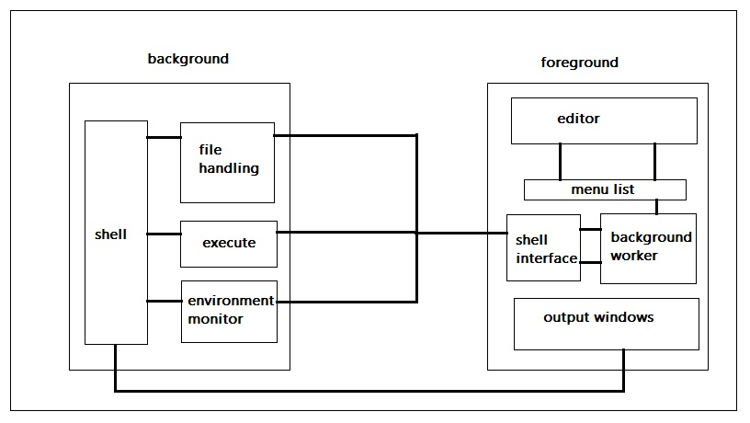

Design Components

Program Flow design:
The client component will have 1 installation on every windows desktop to be used.
It will be developed as an MDI VB application and will have UI as per specifications.
Syntax highlighting, command auto complete, function listing, variable auto-complete/ typecheck will be maintained on local desktop through configuration/ cache files similar to other editors.
Command-line arguments will be defined for communicating with hell component.
When the user requests a Make/ compile/ run, a request will be prepared in a text file with the program ID, user name, application name, and command, etc.. and this file will be put in a configured directory.
For a "run" message, the background worker shall run the program and the output will be redirected to a file, which will be read by the client and put to the UI window.
For a "debug" message, the background worker will check if an open debug session is running for the client. If there is no open session, the background worker will start a debug session with its input-output piped to in-out data files and then the commands will be executed for the instructions in message received.
For every step run, locals, stack, globals and watch variables will be tracked and results sent to output results file which will be displayed in the watch windows on the UI.
When an end debug session is received from client, the background worker will end debug session.
The source files required during debugging will be copied to a temp. directory and the debug session will be run after recompiling the sources and moving the executable to the run time environment.

Component one

Foreground component

Functional Architecture
1. editor
2. menu list
3. shell interface
4. background worker
5. output windows

Component two
Background component

Functional Architecture

1. File handling module

2. Shell execution module

3. Environment monitor

4. Shell

System Specifications.
- Hardware Requirements.
Number of Processors 2 or above (dual core or above)
1 GB RAM or above.
20 GB HDD or above.

- Software Requirements.
Microsoft Windows 7 or above.
Turbo C++ compiler
GCC Compiler Collections.
Intel C/C++ Compiler suite (recommended)
Win AVR build 3.0
or any custom compilers .

- Compatible Compiler Tool Set.
GCC
Turbo C(ANSI 89)
Turbo C++(ANSI 99)
Borland C++
Intel Compiler Suite (requires Windows 7 or Higher)
AVR GCC

(* This software can also run in compatibility mode for Microsoft Windows ® XP service pack 3 with .net 4.0 run time assembly support .)

Feasibility Study: The initial section of this chapter focuses on the practical implementation aspects of the IDE. Whereas the later section of the chapter is dedicated to a comparison between this IDE and any online version of GUI with similar utilities.

Part - 1. Technical aspects of the project SCRAMBLE ® POWER IDE.
The GUI of this IDE has been designed using Microsoft Visual Studio 2010 Professional and the functionality is provided by using tools developed in C to ensure portability over systems.
Since Microsoft Windows Operating systems use windows common runtime library, applications developed with Visual Studio work as if they were a module of the Operating System. Hence applications developed using Microsoft Visual Studio only is capable of exploiting the Operating System’s Environment and certain administrative tools that come as a module of the Operating System. This helps the developer to manage all system wide resources at one single place.

This IDE is designed to help developers debug their programs systematically and analytically at the same time. Some of the features of this IDE are:

- The Project SCRAMBLE ® POWER Code Assist technology.
a) Minimizes syntactical errors considerably.
b) Provides an Intelligent Interface for the developer to track environment changes.
c) Ensures dependencies are addressed.
- The Project SCRAMBLE ® POWER dEBUGGER.
- Monitor real time data dependencies and system state.
- The same debugger supports development of programs for microprocessor and microcontroller environments.
And a list of other new features.
Part -2. Comparison with online version of the utility softwares of similar kind.
With the evolution of web architecture and developments being made in case of Internet Service providers it has been found that file transfer speed over the internet has increased rapidly. Today we have link speeds of over 100MBps even in wireless spectrum, and in a few years the speed might get doubled after introduction of 4G or 5G technology.
The above scenario does encourage a developer to come up with an online version of an IDE, where the IDE can be installed on a server and then be accessed from the client site through a web browser. This would obviously eliminate memory space requirements on client systems. Now, as data transfer delays between client and server would be almost negligible, logically the setup seems perfect. But an IDE is primarily used for debugging purposes, not just for compilation and one time execution of the program under development
Revising the technical terms involved in this section, compilation process simply means using a compiler to convert a program from human readable form to machine readable form. Whereas executing a program means running the executable files that the linker creates using the compiled source files and the other necessary object files. And debugging means removing errors from a program. There lies a thin line of difference between simply executing a program and debugging a program.

In case of simple execution of a program, the generated executable file is loaded to the main memory by the loader and is executed by the processor under the supervision of the OS, whereas during debugging a special program called as debugger is used to invoke the executable file. This program (debugger) keeps track of the lines of source code which get executed along with the stack values and return addresses of the program; also during execution through a debugger if an exception is found in source program the control is returned back to the debugger (a program) while in simple execution the control usually returns back to the OS and the executable program gets unloaded from the RAM.
Coming back to the client-server architecture of an IDE , if we are to debug a program through a web browser then we need to have the debugger installed on the client system. This means that the compiler needs to be installed on the client system as well. Which contradicts the requirements of a client server architecture.
The other view is that the source code can be sent through the browser from client system to the server, where the source code gets compiled at the server site, and the server on completion of compilation process returns a culture neutral executable version of the program. Upon reception of which the executable files gets executed at the client site. Problems associated with such architecture are:
1. Providing a culture neutral file transfer process.
2. Managing network delays (basically Technical Factor beyond human control).
3. Managing assembly level synchronization with client’s processor, since the OS or any Anti-Virus program usually restrict browsers from accessing Active Database Objects (Active X controls) and binary executables directly.
4. Again if the developer opts to execute the program at server’s site then it contradicts the development purpose of the program (programs are generally developed or simulated for individual machines on which they are debugged).
Hence it’s not practically feasible to build a 100% efficient online versions of an IDE which can entirely replace standalone IDE’s that reside on machines where they are supposed to be.
So any IDE’s that need to be designed should always reside on the machine for which development is required or a simulation be created for the same.

TEAM ID: PR CS 03

